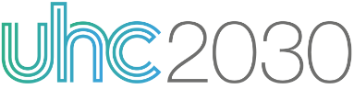
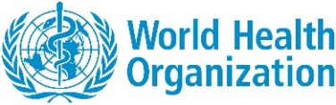
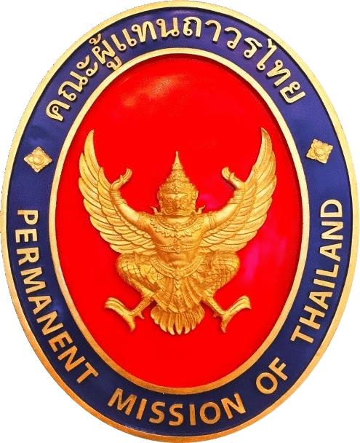
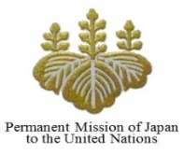
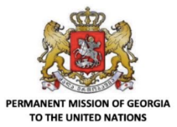
Ministerial Meeting on UHC in the Margin of UNGA75
CONCEPT NOTE

Date: Oct 7-9 TBC
Time: 7:30 – 9:00 AM (TBC)
Platform: Zoom (TBC) – Jessica in contact with WHO HQ
Interpretation: French – English (TBC)
Registration link: XXX

Hosts: Group of Friends of UHC and the World Health Organization
Sponsored by: UHC2030, United Nations Foundation

BACKGROUND
A year ago this September, world leaders came together to endorse the Political Declaration on Universal Health Coverage (UHC). Since that moment, the world has been faced with a global health and human security crisis unparalleled in recent history, the health and socioeconomic implications of which pose a significant threat to progress made toward the achievement of the Sustainable Development Goals (SDGs).

Prior to the COVID-19 pandemic, the world was already at risk of missing SDG targets on UHC. The 2019 Monitoring Report on UHC found that although much progress has been made over the past few decades, the pace of progress has slowed since 2010. Only between one half and one third of the world’s population have access to essential health services. Progress must markedly accelerate – and coverage needs to double – to reach the SDG target of UHC for all by 2030. According to the WHO global pulse survey, 90% of countries report disruptions to essential health services since COVID-19, with low- and middle-income countries reporting the greatest difficulties. Further, the percentage of the population impoverished by out-of-pocket health spending has been on the rise since 2000, and the World Bank now estimates that the COVID-19 pandemic will push at least 71 million into extreme poverty.

The picture is sobering, but investments in health systems oriented toward UHC offer solutions for responding to the current situation and building back better. Such health systems are built on a robust foundation of primary health care (PHC), adequately resourced to maintain continuity of essential services while providing emergency care during shocks, and have the capacity to protect patients from financial risk.

As we commemorate the one-year anniversary of the HLM on UHC, it is the opportune moment to reflect on the commitments made at the High-level Meeting on UHC, taking into account the lessons learned and fault lines exposed during COVID-19. Beyond the immediate challenges and long-term consequences of COVID-19, the pandemic presents an opportunity to develop more equitable and resilient health systems, better aligned with the principles of universal health coverage, in order to limit direct mortality and avoid indirect mortality, ensuring better health and well-being for all.

OBJECTIVES
- Highlight the urgency of fulfilling the commitments made in the Political Declaration of the High-Level Meeting on Universal Health Coverage (2019)
- Share best practices/lessons learned and how UHC has contributed to effective COVID-19 response and good health outcomes
- Reflect on the opportunity for countries to accelerate and scale up action on health system transformation and better integrate health and financing dialogues, for health and human security

PROPOSED PROGRAMME
Hosts: PRs of Japan, Georgia and Thailand, WHO
Moderator: Ambassador Elizabeth Cousens, President and CEO of United Nations Foundation (TBC)
OPENING SEGMENT (15 min / 3 min each)
Political messages and global solidarity
- SG/DSG (TBC)
- WHO DG (TBC)
- H.E. Mr. MOTEGI Toshimitsu, Foreign Minister of Japan
- Georgia, Health or Foreign Minister (TBC)
- Thailand, Foreign Minister (TBC)

MINISTERIAL PANEL (15 min / 5 min each)
National Governance and best practices
- France (TBC)
- Mexico (TBC)
- Senegal (TBC)

OPEN DISCUSSION / Q&A (15 min)

THEMATIC DISCUSSION (15 min / 5 min each)
Essential Services, Access to Medicines, Financial Protection – the implementation
- Dr. Seth Berkley, CEO of Gavi – access to medicines
- Dr. Khuat Thi Hai Oanh, Executive Director of the Center for Support Community Development Initiatives (SCDI) and UHC2030 Advisory Group member – accountability / accessibility and equity / leave no one behind
- Private Sector Representative (request from WUN, to be nominated by UHC2030 or UNF BCUN)
- Multilateral organization (World Bank, UNICEF, UNDP?) – essential services / financial protection

OPEN DISCUSSION/Q&A (15 – 30 min)

